WIPRO EXERCISE
Steps to build my-website
Step 1: Create Project Directory
Open your terminal and run:
mkdir my-website
cd my-website

Step 2: Create Website Content
Create a file named index.html with the following content:
File: index.html
<!DOCTYPE html>
<html lang="en">
<head>
<meta charset="UTF-8">
<title>My Docker Website</title>
</head>
<body>
<h1>Welcome to My Docker Website!</h1>
<p>This is a simple static website hosted using Nginx and Docker.</p>
</body>
</html>

Step 3: Create Dockerfile
Create a file named Dockerfile in the same directory:
File: Dockerfile
# Use the official Nginx image from Docker Hub
FROM nginx:alpine

# Copy the website files to the Nginx HTML directory
COPY index.html /usr/share/nginx/html/index.html

# Expose port 80 for the web server
EXPOSE 80

# Start Nginx when the container launches
CMD ["nginx", "-g", "daemon off;"]

Step 4: Build and Run the Docker Container
- Build the Docker image:
- docker build -t my-website .
- Run the Docker container (map container port 80 to host port 8080):
- docker run -d -p 8080:80 --name my-website-container my-website

Step 5: Access the Website
Open your browser and go to:
👉 http://localhost:8080
You should see the "Welcome to My Docker Website!" page.

Step 6: Stop and Clean Up (Optional)
- Stop and remove the container:
- docker stop my-website-container
- docker rm my-website-container
- Remove the Docker image:
- docker rmi my-website

SCREENSHOT OF THE STEPS
STEP-1
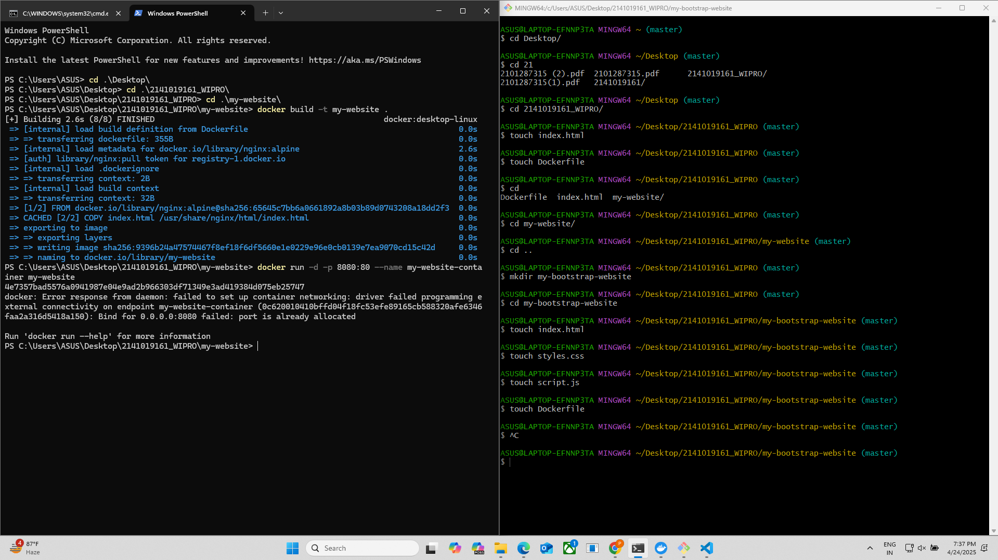
STEP-2
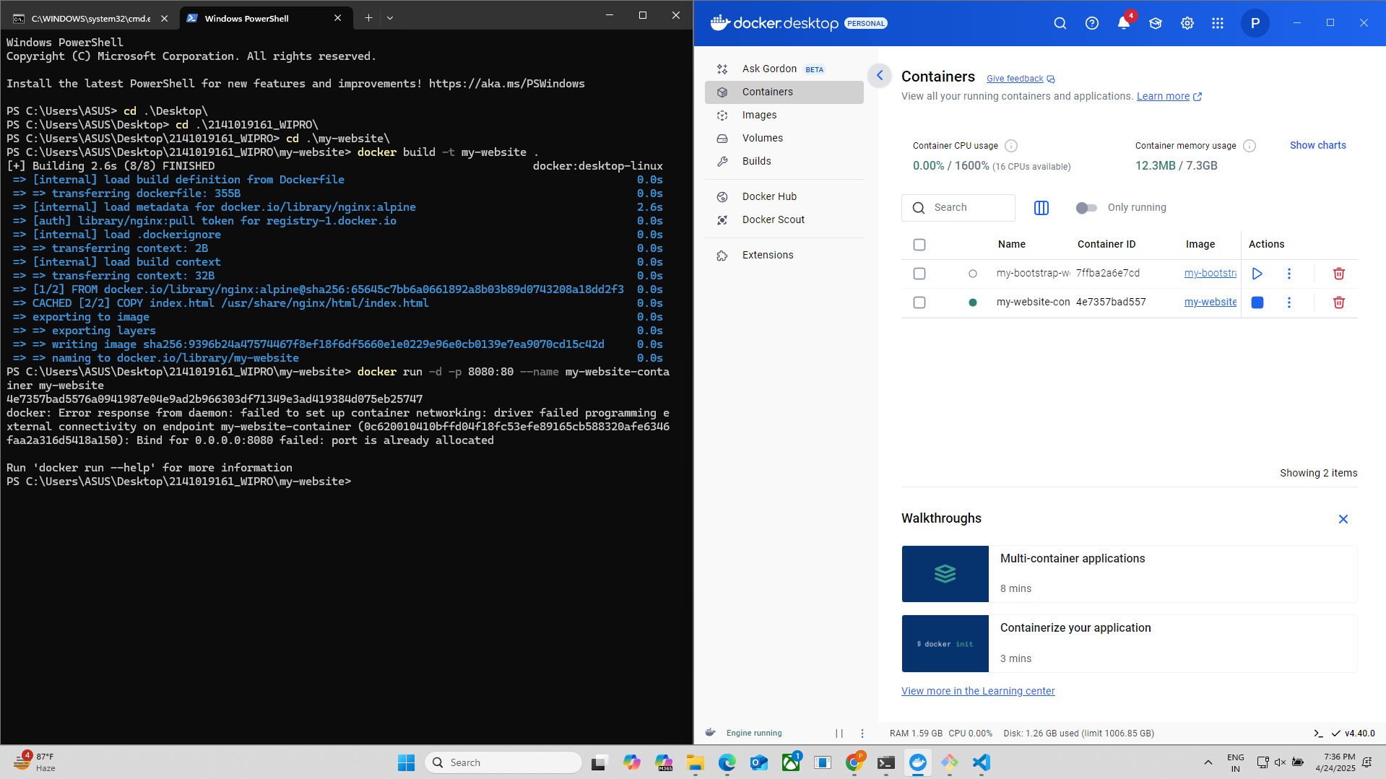
STEP-3
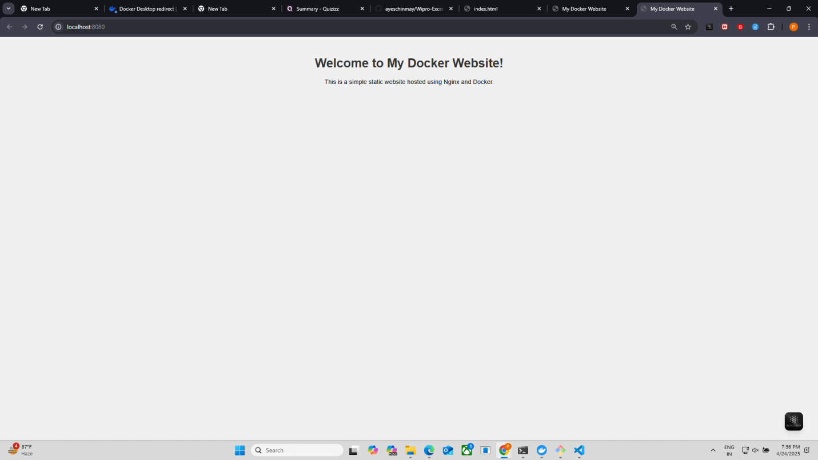

Steps to build my-bootstrap-website

Step 1: Create Project Directory
Open your terminal and run:
mkdir my-bootstrap-website
cd my-bootstrap-website

Step 2: Create Website Files

File: index.html
<!DOCTYPE html>
<html lang="en">
<head>
<meta charset="UTF-8">
<title>My Docker Website</title>
<meta name="viewport" content="width=device-width, initial-scale=1">

<!-- Bootstrap CSS CDN -->
<link href="https://cdn.jsdelivr.net/npm/bootstrap@5.3.0/dist/css/bootstrap.min.css" rel="stylesheet">

<!-- Custom CSS -->
<link rel="stylesheet" href="styles.css">
</head>
<body>
<div class="container text-center mt-5">
<h1>Welcome to My Docker Website!</h1>
<p class="lead">
This website uses Bootstrap, jQuery, and custom CSS, hosted with Nginx and Docker.
</p>

<button id="toggleButton" class="btn btn-primary mt-3">Toggle Message</button>
<p id="message" class="mt-3 d-none">Hello! This message was toggled using jQuery.</p>
</div>

<!-- jQuery CDN -->
<script src="https://code.jquery.com/jquery-3.7.1.min.js"></script>

<!-- Custom JS -->
<script src="script.js"></script>
</body>
</html>

File: styles.css
body {
background-color: #f8f9fa;
font-family: Arial, sans-serif;
}

h1 {
color: #343a40;
}

.lead {
color: #6c757d;
}

File: script.js
$(document).ready(function() {
$('#toggleButton').click(function() {
$('#message').toggleClass('d-none');
});
});

Step 3: Create Dockerfile
File: Dockerfile
# Use the official Nginx image from Docker Hub
FROM nginx:alpine

# Copy website files to the Nginx HTML directory
COPY index.html /usr/share/nginx/html/
COPY styles.css /usr/share/nginx/html/
COPY script.js /usr/share/nginx/html/

# Expose port 80 for the web server
EXPOSE 80

# Start Nginx when the container launches
CMD ["nginx", "-g", "daemon off;"]

Step 4: Build and Run the Docker Container
- Build the Docker image:
docker build -t my-bootstrap-website .
- Run the Docker container:
docker run -d -p 8080:80 --name my-bootstrap-website-container my-bootstrap-website

Step 5: Access the Website
Open your browser and visit:
📍 http://localhost:8080
You should see a Bootstrap-styled page with a button and a message that toggles using jQuery.

Step 6: Stop and Clean Up (Optional)
- Stop and remove the container:
docker stop my-bootstrap-website-container
docker rm my-bootstrap-website-container
- Remove the Docker image:
docker rmi my-bootstrap-website

SCREENSHOT OF THE STEPS
STEP-1

STEP-2
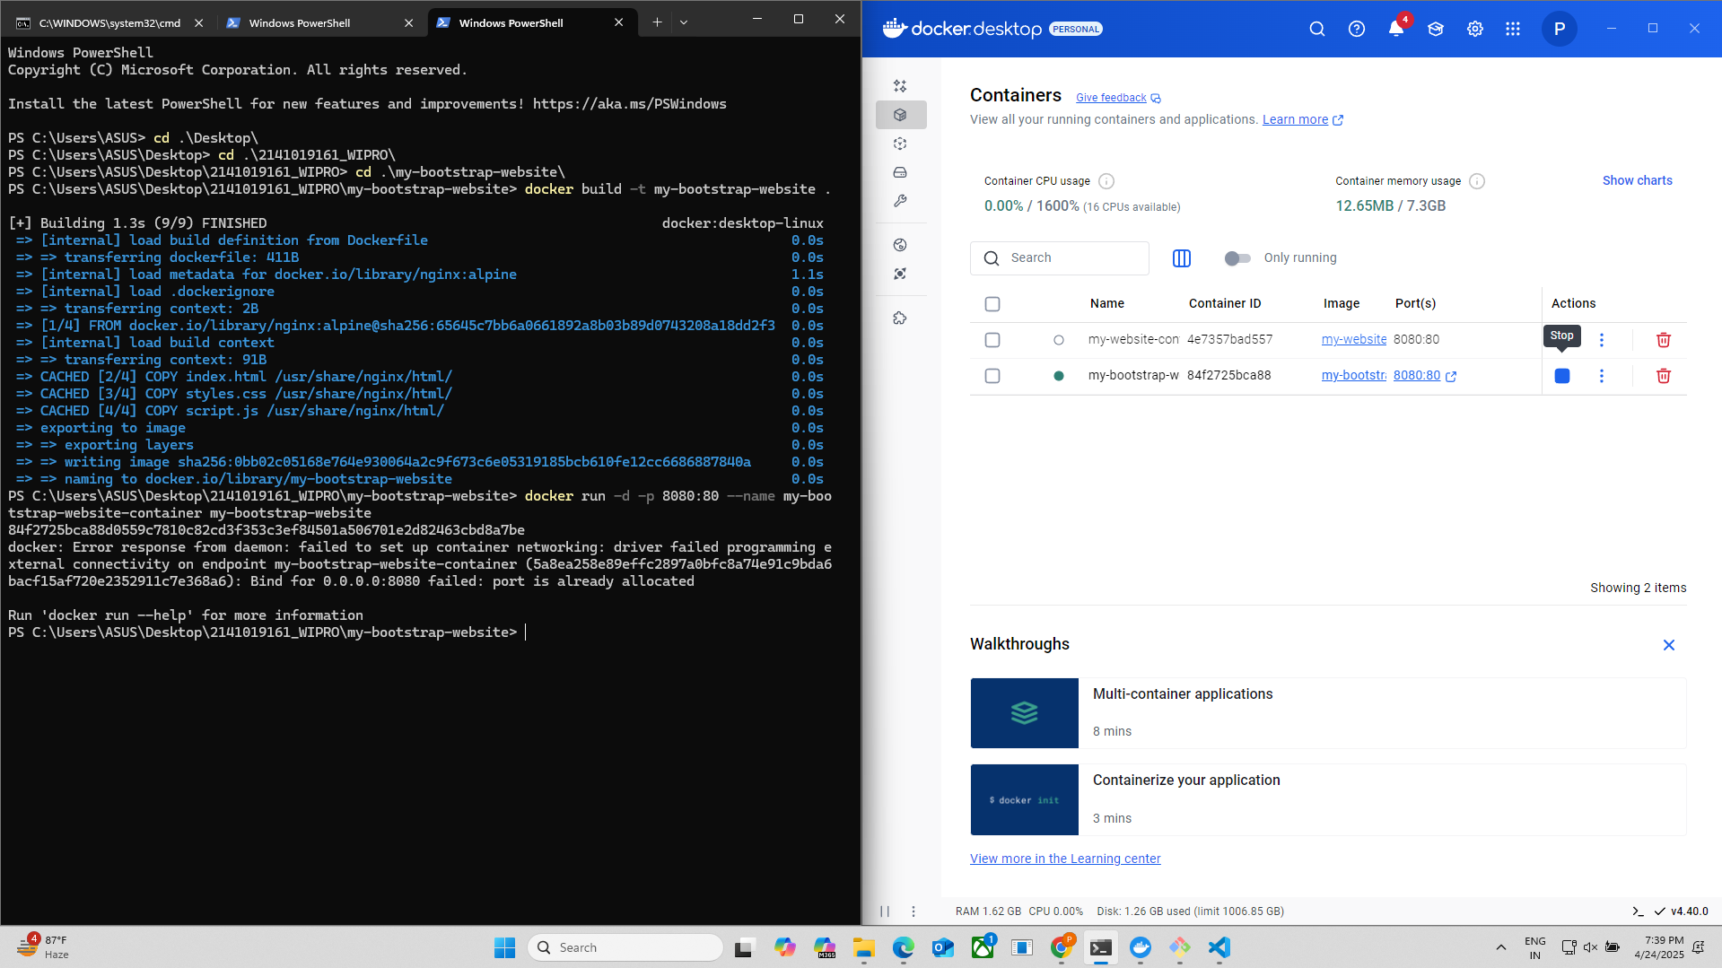
STEP-3
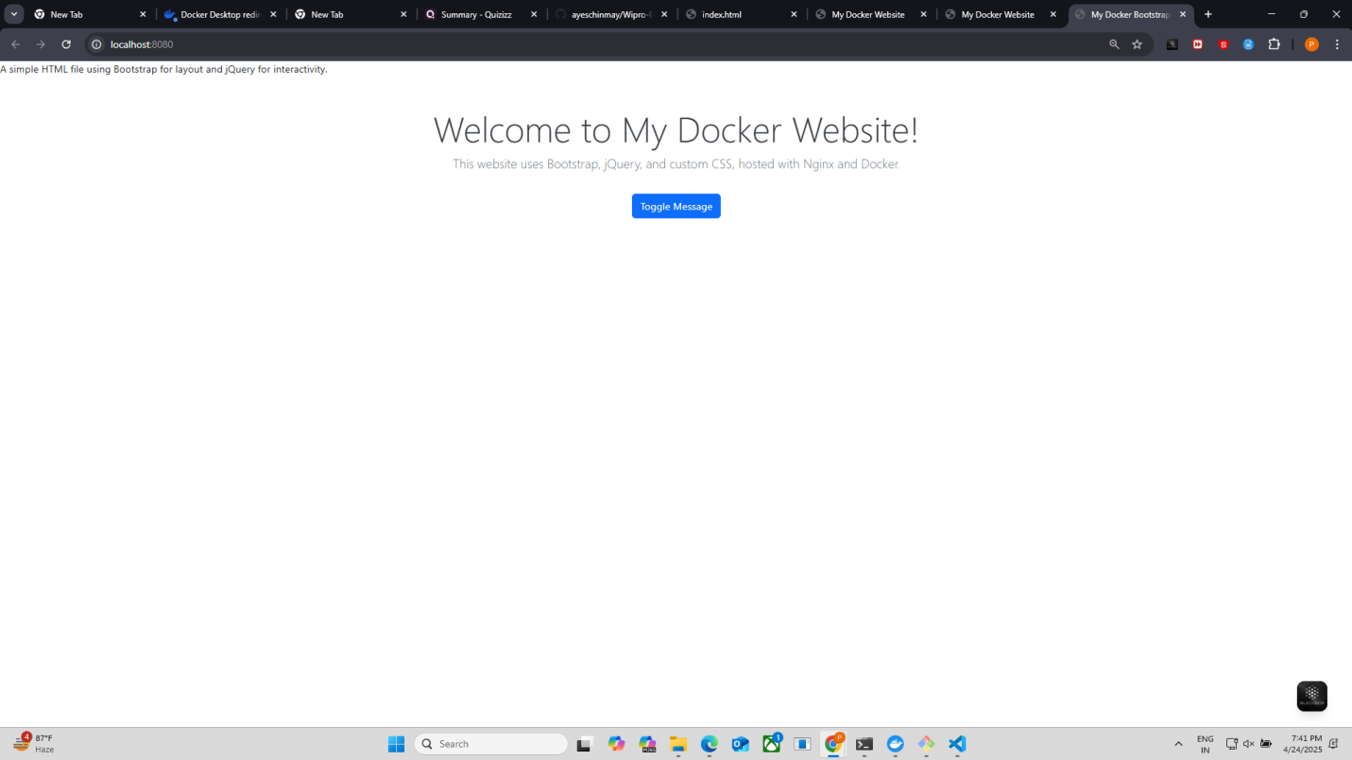
STEP-4
